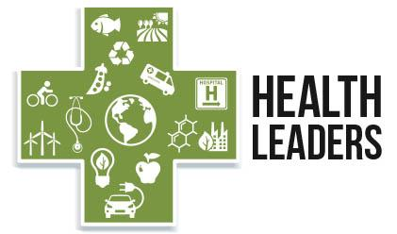
Health Leaders Fellowship
April 2021 – January 2022
Application Form: Due January 25, 2021

To apply for the Health Leaders Fellowship please complete and submit this form, along with a copy of your current resume to Mara Herman at the Ecology Center (contact information at bottom of page 3).

Acceptance into the program is based, in part, on a commitment to:
- Attend virtual events and experiences, and participate in 6-7 webinars;
- Complete a minimum 20 hours of project work to fulfill guided practicum requirement;
- Apply what you learn to your work and/or in your community.

For a description of the program details please see www.ecocenter.org/health-leaders

Name:________________________________________________________________ Credentials: ____________________________________

E-Mail: _________________________________________________________________ Phone: (_________) ____________ - _______________

Home Address: __________________________________________________________________________________________________________
Organization(s)/institution(s) you are affiliated with: __________________________________________________________

_________________________________________________ Title/Position: ________________________________________________________

Work Address (if applicable): ________________________________________________________________________________________

1. Why are you interested in learning more about the connections between health and the environment?

Continue on next page

2. What experiences or skills would you bring to this program and what skills/experience are you hoping to gain from this program?

3. How do you plan to apply the civic engagement tools and issue-specific knowledge you learn through this program?

4. Are you currently active in environmental health related efforts? If so, please describe.

Continue on next page

5. Is there anything else you would like us to know about you? (optional)

6. Please identify your top area of interest by checking the box:
  - Toxic Chemicals and Health ☐
  - Cleaner Energy & Climate Change and Health ☐

**Do you also have an interest in sustainable food systems?

7. How did you hear about this fellowship? (please circle option below)
- Ecology Center Website
- Friend/colleague
- E-mail from the Ecology Center
- Presentation from Ecology Center staff member
- Other, please specify: __________________________________

8. Do you have any dietary restrictions? If so please list. ________________________________________________________

9. Resume – Please submit a current resume with your application

** TIMELINE **

Application Deadline: applications will be accepted on a rolling basis until January 25th, 2021
Communication with finalists via phone or e-mail (prospective fellows may be interviewed):
January 11th – January 25th
Final Notification/Applicants accepted: February 12th, 2021

Please return your completed application via e-mail or mail to:
Mara Herman, Ecology Center
339 E. Liberty, Suite 300
Ann Arbor, MI 48104

E-mail: healthleaders@ecocenter.org, Phone: (734) 369 – 9264, Website: http://www.ecocenter.org/health-leaders

